Task 2 - Mean Variance Efficient Frontier – Industry Portfolios
We construct the MV efficient frontier for 30 industry portfolios (January 1980–December 2025) using three estimators to assess the impact of shrinkage on portfolio optimisation.

We estimate three frontiers: (i) sample estimates of means and covariance, (ii) Bayes-Stein (BS) shrinkage of expected returns towards a common grand mean to reduce estimation noise (Jorion, 1986), and (iii) BS shrinkage combined with Ledoit–Wolf (LW) covariance shrinkage for a well-conditioned covariance matrix.

For each frontier we highlight the GMV and tangency (maximum Sharpe ratio) portfolios, using the average risk-free rate over the sample period.

Efficient Frontier Estimation
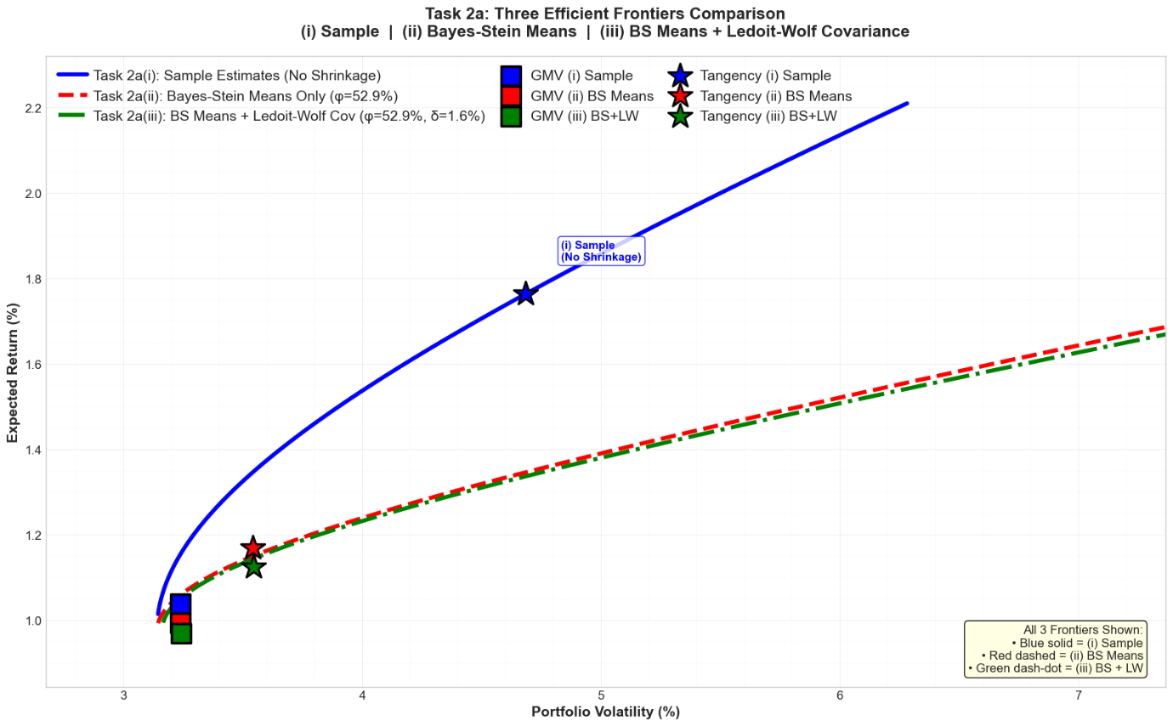
Figure 2.1: Industry Portfolios: Mean-Variance Efficient Frontiers (Sample vs BS vs BS+LW)

The sample frontier (blue) shows the most optimistic risk return trade off as it pushes further outwards. This aligns with the observation that mean-variance optimisation may lead to overfitting of the sample data, resulting in excessively aggressive 'optimal' portfolios, which is often referred to as 'error maximisation' (Michaud, 1989). The application of BS shrinkage results in an inward and downward shift of the mean vector (red), indicating a more conservative outlook on expected returns when accounting for estimation error. The inclusion of the LW covariance shrinkage ( green) results in a slight adjustment. Figure 2.1 illustrates that the green and red curves are nearly identical, suggesting that the effect of covariance shrinkage on this dataset is minimal.

Overall, Figure 2.1 indicates that the primary factor contributing to the disparity among the three frontiers is mean shrinkage, rather than covariance shrinkage. The GMV portfolios exhibit close clustering and the tangency portfolios exhibit significant variation across different estimators. This can be observed as the sample tangency portfolio lies on the blue frontier at a noticeably higher return and volatility. In contrast, the shrinkage-based tangency portfolios are situated on the more conservative red/green frontier, which is associated with lower expected returns. This highlights the sensitivity of Sharpe-maximising portfolios to mean estimation error.

GMV and Tangency Portfolio statistics
Tables 2.1 and 2.2 report the monthly expected excess returns, volatility and Sharpe ratio for both the GMV and Tangency portfolios under each estimator.

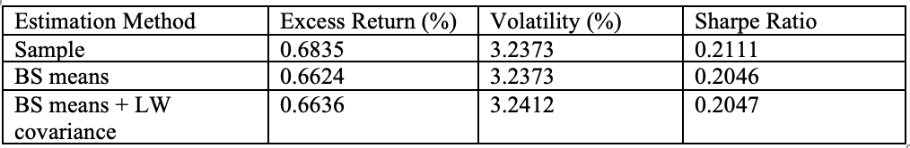
Table 2.1: GMV portfolio statistics (monthly, excess returns)
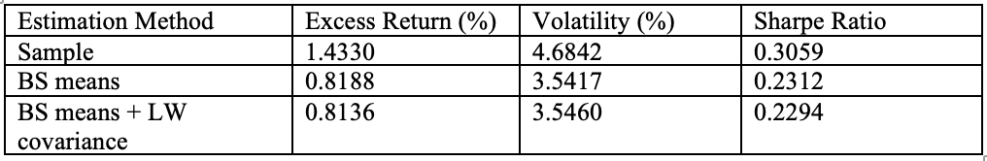
Table 2.2: Tangency portfolio statistics (monthly, excess returns)

Table 2.1 demonstrates that the GMV portfolio remains consistent regardless of the estimator used. The volatility and Sharpe ratio remain constant at approximately 3.24% and the expected excess returns have minor fluctuations. This suggests that the adjustments for shrinkage have little impact on the portfolios that have the lowest risk profiles. This outcome is expected, as the GMV is influenced by the covariance structure rather than the mean vector.

In contrast, the results presented in Table 2.2 indicate that the tangency portfolio exhibits a greater sensitivity to shrinkage. Using the sample estimation method, the highest in-sample Sharpe ratio is recorded at 0.3059. This is likely due to upward bias, as the optimiser could depend on the noise in the sample mean estimates. After implementing BS shrinkage the tangency portfolio becomes more conservative, with expected excess returns declining from 1.43% to approximately 0.89%. The observed volatility decreases from 4.86% to an approximate level of 3.54%. ​​The Sharpe ratio decreases to approximately 0.23, corresponding with a decline in "error maximisation." Using shrinkage reduces both anticipated excess returns and volatility, leading to a more stable portfolio, even with a slight decrease in its risk-adjusted return.

Task 3 - Mean Variance Efficient Frontier – Stock Portfolios
We construct the MV efficient frontier using 30 individual U.S. stocks — one per industry — to assess how individual security risk compares to diversified industry portfolios. To ensure a valid comparison, stock and industry frontiers are estimated over the same sample period, limited by the shortest available stock history.

 | Industry | Ticker | Company | Data From
1 | Food Products | KO | Coca-Cola Co. | Jan 1980
2 | Beer & Liquor | TAP | Molson Coors Beverage | Jan 1980
3 | Tobacco Products | MO | Altria Group (Philip Morris) | Jan 1980
4 | Recreation | HAS | Hasbro Inc. | Mar 1980
5 | Printing and Publishing | NYT | New York Times Co. | Jan 1980
6 | Consumer Goods | PG | Procter & Gamble Co. | Jan 1980
7 | Apparel | VFC | VF Corporation | Mar 1980
8 | Healthcare | JNJ | Johnson & Johnson | Jan 1980
9 | Chemicals | DD | DuPont de Nemours | Jan 1980
10 | Textiles | TXT | Textron Inc. | Jan 1980
11 | Construction | PHM | PulteGroup Inc. | Mar 1980
12 | Steel Works Etc | NUE | Nucor Corporation | Mar 1980
13 | Fabricated Products | ITW | Illinois Tool Works | Jan 1980
14 | Electrical Equipment | ETN | Eaton Corporation | Jan 1980
15 | Automobiles and Trucks | F | Ford Motor Company | Jan 1980
16 | Railroad Equipment | UNP | Union Pacific Railroad | Jan 1980
17 | Industrial Metal Mining | NEM | Newmont Mining Corp. | Mar 1980
18 | Coal | FMC | FMC Corporation | Mar 1980
19 | Petroleum and Natural Gas | XOM | ExxonMobil Corporation | Jan 1980
20 | Utilities | DUK | Duke Energy Corp. | Mar 1980
21 | Communications | LUMN | Lumen Technologies (CenturyTel/CenturyLink) | Mar 1980
22 | Personal and Business Services | ADP | Automatic Data Processing | Mar 1980
23 | Business Equipment | AAPL | Apple Inc. | Dec 1980
24 | Business Supplies | IP | International Paper Co. | Jan 1980
25 | Transportation | LUV | Southwest Airlines Co. | Jan 1980
26 | Wholesale | SYY | Sysco Corporation | Jan 1980
27 | Retail | WMT | Walmart Inc. | Jan 1980
28 | Restaurants | MCD | McDonald's Corporation | Jan 1980
29 | Banking and Finance | JPM | JPMorgan Chase & Co. | Mar 1980
30 | Other | MMM | 3M Company | Jan 1980
Table 3.1: Stock Choices

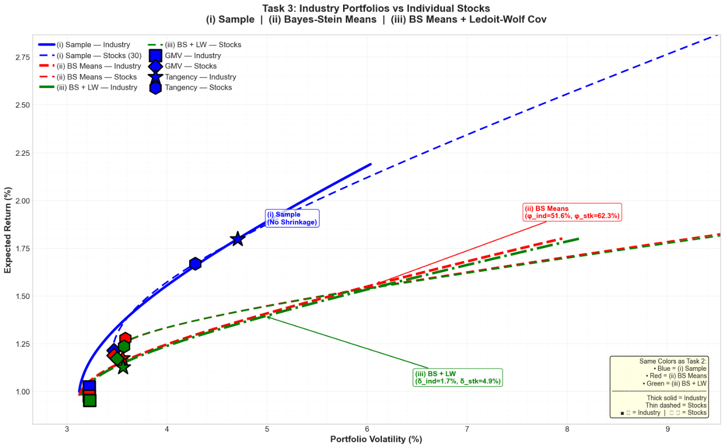
Figure 3.1: Industry Portfolios vs Individual Stocks

Figure 3.1 illustrates the efficient frontiers for both the 30 industries and the 30 stocks across the three estimators. The stock frontier is advancing to the right across estimators. This indicates that for a specified expected return, portfolios composed of stocks imply greater volatility. This is anticipated as diversified portfolios show reduced idiosyncratic volatility compared to individual assets; hence, the overall risk level begins from a lower baseline when they are combined (DeMiguel, Garlappi, and Uppal, 2009). The idiosyncratic noise is mitigated within the industry portfolio itself.

The shrinkage data indicate that estimating error is stronger for stocks. The stock mean shrinkage is 62.3%, and the covariance shrinkage is 4.9%, in contrast to the industry mean shrinkage of 51.6% and covariance shrinkage of 1.7%. The higher shrinkage intensity for stocks indicates that expected return estimations are more volatile for individual securities (Chopra, Hensel, and Turner, 1993); hence, Bayes-Stein applies a stronger mean shrinkage. The covariance shrinkage is minimal in both instances, indicating that the sample covariance matrix remains rather constant throughout this extended sample period.
The GMV portfolio volatility for stocks (3.4694%) slightly exceeds that of industries (3.2219%), due to reduced diversification. The tangency portfolio risk is also similar for both stocks (4.2832%) and industries (4.7052%). The frontier shift and data indicate that industry portfolios exhibit a superior risk-return trade-off compared to portfolios constructed from individual stocks.

Task 4 – Capital Market Line and Comparison with the Risky-Only Frontier
Using the 30 industry portfolios and the above risk-free rate, the tangency portfolio was computed for the portfolio that maximises the Sharpe ratio:
Metric | Value
Tangency portfolio return | 1.7627% / month
Tangency portfolio volatility | 4.6842% / month
Risk-free rate | 0.3297% / month
Maximum Sharpe ratio | 0.3059
Table 4.1: Key Results
The CML slope (SR = 0.306) represents the highest reward-to-risk ratio achievable. The tangency portfolio lies on the risky frontier at σ = 4.68%, confirming internal consistency.
Metric | Risky Frontier | CML
Frontier shape | Curved (hyperbola) | Straight line
Minimum volatility | 3.24% | 0% (hold RF only)
Return at σ = 0 | Not available | 0.3297%
Tangency return | 1.7627% | 1.7627%
Tangency volatility | 4.6842% | 4.6842%
Maximum Sharpe ratio | 0.3059 | 0.3059
Return at GMV volatility (3.24%) | 1.0132% | 1.3201%
CML advantage at GMV vol | — | +0.3069pp
Return at median vol (4.21%) | 1.6052% | 1.6186%
CML advantage at median vol | — | +0.0134pp
Table 4.2: Comparison: CML vs Risky-Only Efficient Frontier
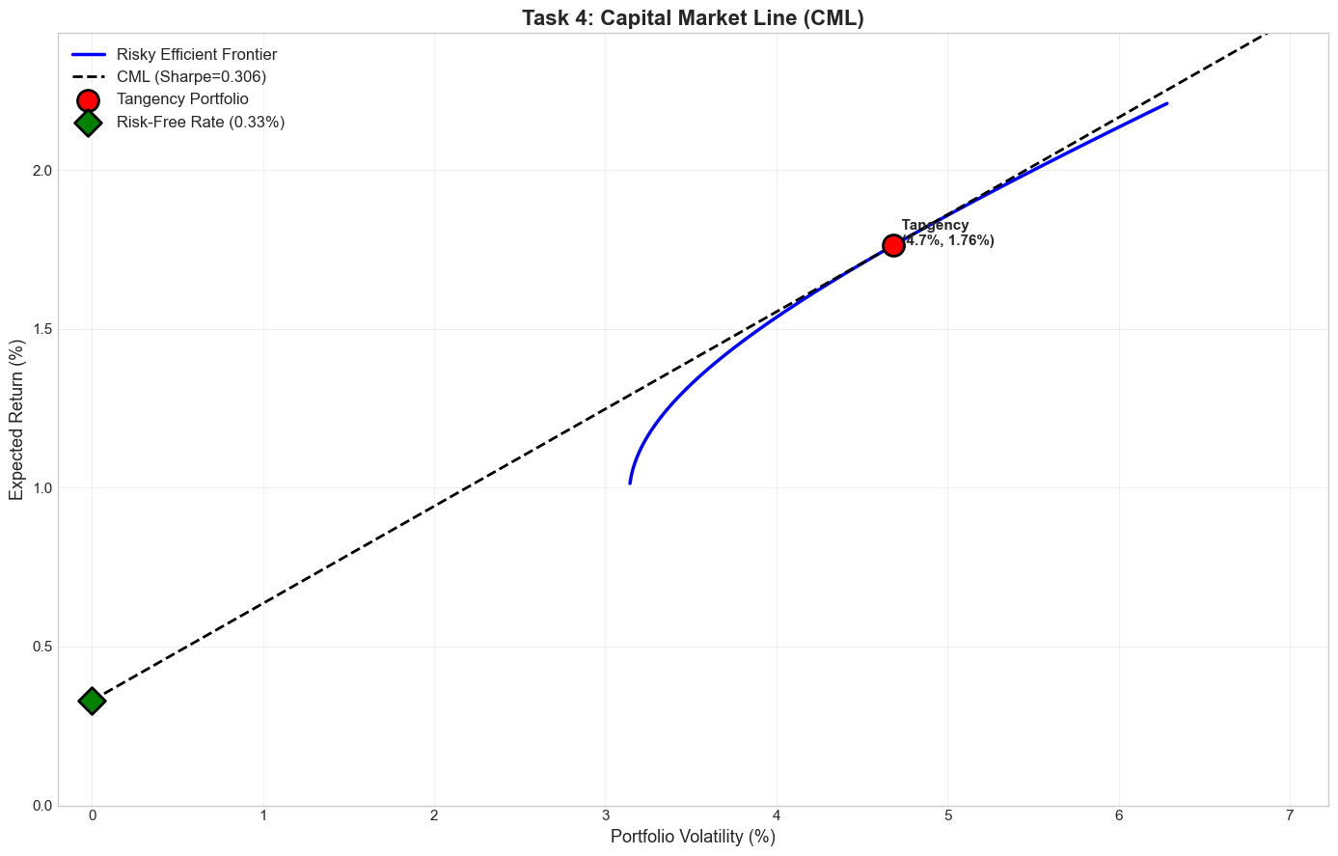
Figure 4.1: Capital Market Line (CML)
Introducing the risk-free asset linearises the frontier into the CML, with every feasible portfolio now a combination of the tangency portfolio and the risk-free asset (Tobin, 1958). The CML strictly dominates the risky-only frontier: at any given volatility level a higher expected return is available. The tangency portfolio (SR = 0.306) emerges as the unique optimal risky portfolio, consistent with Tobin's separation principle and Markowitz (1959).

Task 5 – Fama–French Factor Models

5.1 Factor Opportunity Sets (Excess Return Framework)
Fama–French factors are reported as excess returns, so industry returns are also converted to excess returns to allow a like-for-like comparison (Fama and French, 1993; 2015). All CMLs pass through the origin and their slopes equal the tangency Sharpe ratio (Sharpe, 1966).
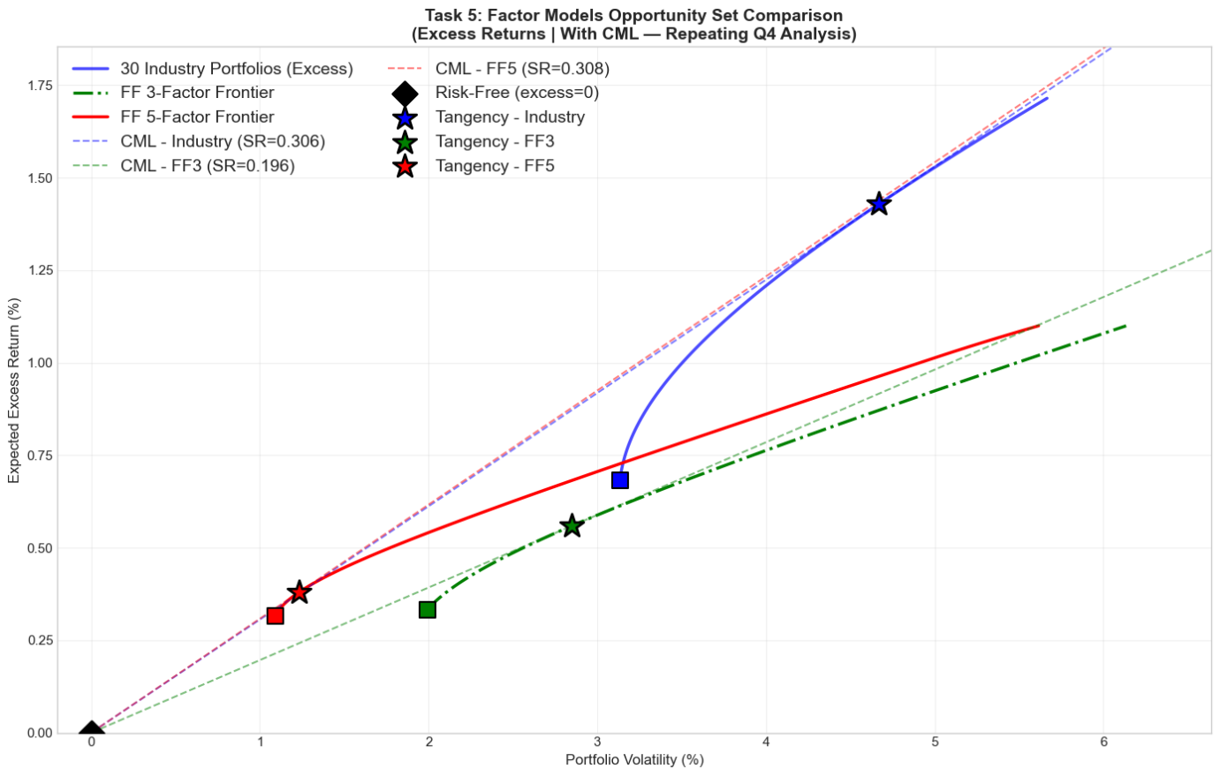
Figure 5.1: Factor Models Opportunity Set Comparison
Opportunity Set | GMV E[Re]% | GMV Vol% | GMV SR | Tan E[Re]% | Tan Vol% | Tan SR
30 Industries (Excess) | 0.6826 | 3.2279 | 0.2115 | 1.4281 | 4.6667 | 0.3060
FF3 Factors | 0.3329 | 2.0603 | 0.1616 | 0.5592 | 2.8496 | 0.1962
FF5 Factors (2×3) | 0.3153 | 1.3255 | 0.2379 | 0.3797 | 1.2317 | 0.3083
Table 5.1: Key findings of Factor Models Opportunity Set Comparison
FF5 achieves the highest Sharpe ratio (0.308), marginally above industries (0.306), while FF3 lags at 0.196. Adding RMW and CMA to the factor set meaningfully expands the opportunity set, confirming that FF5 dominates FF3 in mean-variance terms. However, the FF5 advantage over the 30-industry universe is economically small, suggesting that broad industry allocation already captures most of the attainable efficiency.
The industry tangency Sharpe ratio in excess return space (0.306) is negligibly different from the total return estimate (0.306), confirming Tobin's (1958) result that subtracting a constant risk-free rate does not alter optimal weights or Sharpe ratios.

Task 6 – Mean Variance Efficient Frontier – Investable ETF Proxies
We construct MV efficient frontiers using investable ETFs as practical proxies for FF factors (Faff, 2003). Panel A: FF3 proxies (SPY, IWM, IWD), 2005–2025 (T = 251); Panel B: FF5 proxies (adding QUAL, USMV), 2014–2025 (T = 143).
The ETF proxies used are summarised in Table 6.1.
Factor | Paper Portfolio | ETF Proxy | Ticker
Market | Mkt-RF | S&P 500 | SPY
Size | SMB | Russell 2000 | IWM
Value | HML | Russell 1000 Value | IWD
Profitability | RMW | Quality Factor | QUAL
Investment | CMA | Minimum Volatility | USMV
Table 6.1: Investable ETF proxies for FF factors
All ETF returns are converted to excess returns to be consistent with FF factor series, reported in excess return format.

Efficient Frontier Estimation

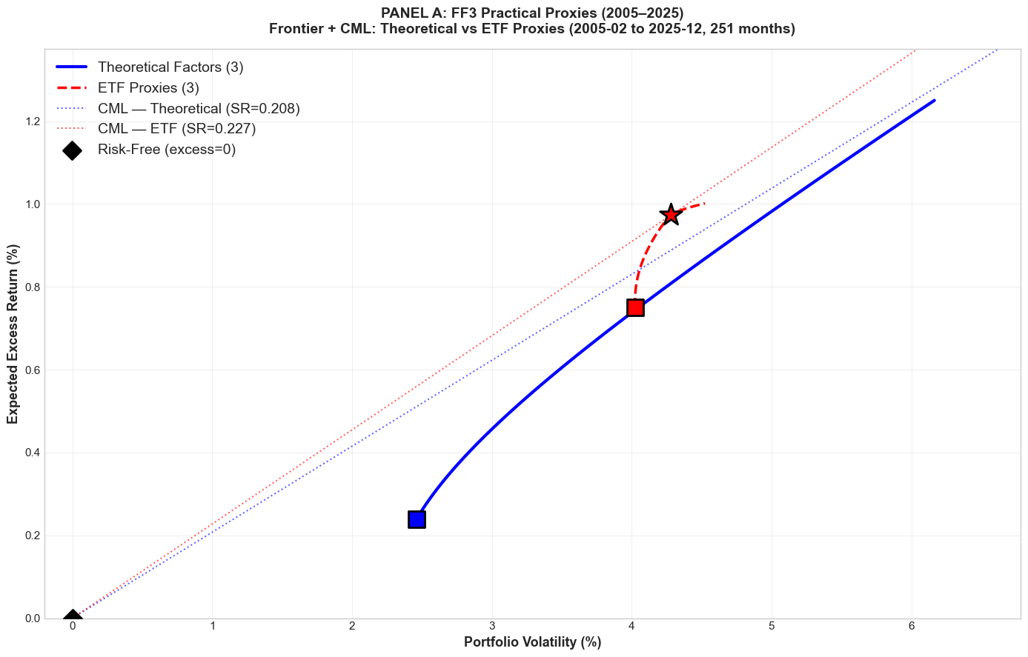
Figure 6.1: Panel A – FF3 Proxies vs Theoretical Factors (2005–2025, T = 251)
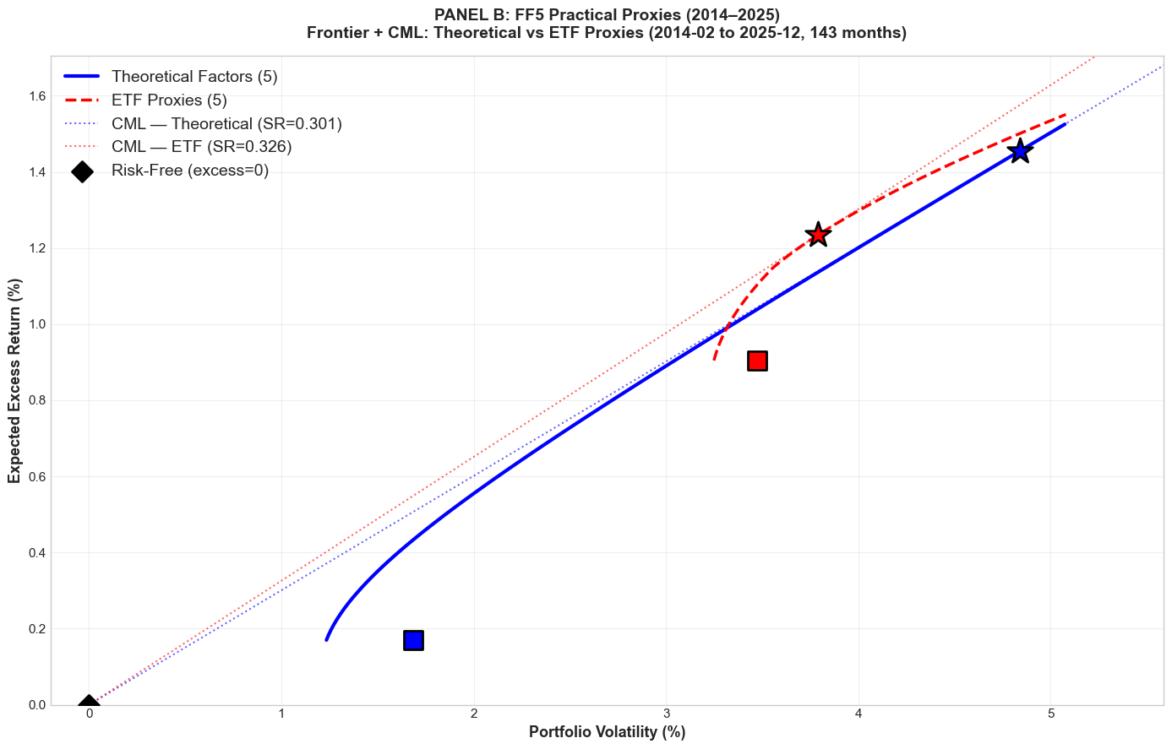
Figure 6.2: Panel B – FF5 Proxies vs Theoretical Factors (2014–2025, T = 143)

Factor | ETF Proxy | Correlation
Mkt-RF | SPY | 0.994
SMB | IWM | 0.693
HML | IWD | 0.304
RMW | QUAL | 0.089
CMA | USMV | −0.069
Table 6.2: Correlation Between ETF Proxies and Theoretical FF Factors (Full matched sample)
Table 6.2 reveals a sharp divergence in proxy quality. SPY tracks the market factor with near-perfect correlation (ρ = 0.995). IWM moderately approximates SMB (ρ = 0.690) by capturing the long leg of the size premium. However, IWD weakly tracks HML (ρ = 0.367), while QUAL and USMV bear essentially no resemblance to the theoretical RMW and CMA factors (ρ < 0.10), reflecting the fundamental difference between long-only ETFs and the long–short zero-investment factor construction (Fama and French, 2015).

Portfolio Set | Period | T | Tan SR | Tan Vol% | GMV SR | SR Gap
Theoretical FF3 | 2005–2025 | 251 | 0.207 | 0.208 | 0.097 | —
ETF FF3 Proxies | 2005–2025 | 251 | 0.227 | 0.186 | 0.227 | +0.020
Theoretical FF5 | 2014–2025 | 143 | 0.301 | 0.169 | 0.101 | —
ETF FF5 Proxies | 2014–2025 | 143 | 0.326 | 0.190 | 0.260 | +0.025
Table 6.3: Efficient Frontier Comparison — Theoretical Factors vs ETF Proxies
Table 6.3 shows a counterintuitive result: ETF proxies achieve higher tangency Sharpe ratios than theoretical factors in both panels (Panel A: 0.227 vs 0.208; Panel B: 0.326 vs 0.301). This arises because the long–short factors delivered subdued mean excess returns over these specific windows, while the ETF universe benefited from the 2005–2025 equity bull market. This is not evidence of genuine ETF superiority but reflects the sensitivity of in-sample Sharpe comparisons to the evaluation window (Michaud, 1989; DeMiguel et al., 2009).

Task 7 – In-Sample and Out-of-Sample Performance Evaluation
In this section, we evaluate whether the portfolios remain optimal out-of-sample compared to in-sample. Mean–variance optimisation is highly sensitive to error maximisation, particularly in expected return estimates (Michaud, 1989; Chopra, Hensel and Turner, 1993). Therefore, portfolios that appear efficient in-sample may fail to remain efficient when evaluated on new data.
We divide the full sample into two groups: January 1980–December 2002 (in-sample) and January 2003–December 2025 (out-of-sample). Efficient frontiers are first estimated in-sample for the 30 industry portfolios and the Fama–French 5 factors, including the risk-free asset. From each frontier, the Global Minimum Variance (GMV) and Tangency portfolios are selected and then evaluated out-of-sample using fixed weights.

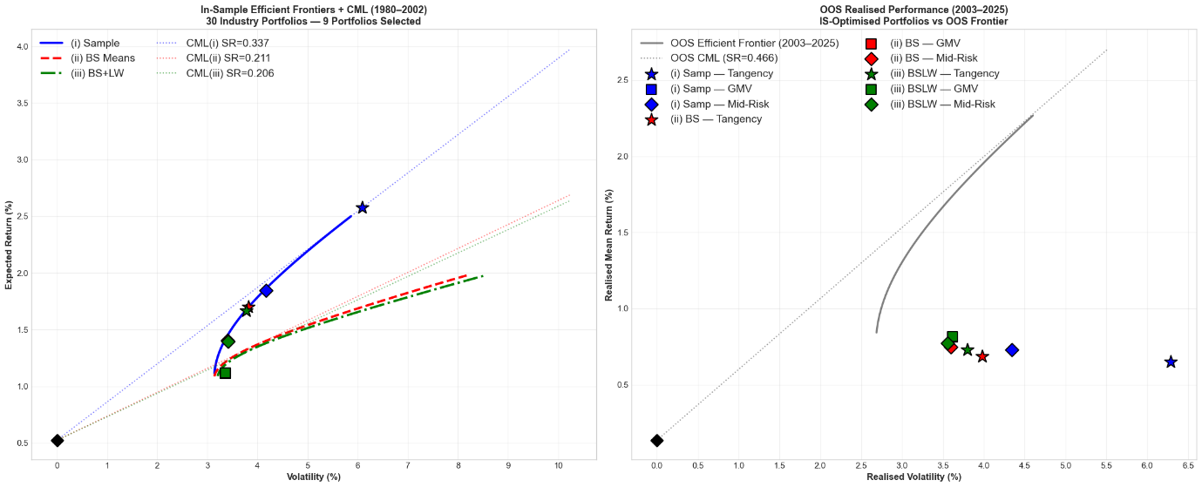Figure 7.1: In-Sample vs Out-of-Sample Efficient Frontier – 30 Industry Portfolios
In Figure 7.1, the tangency portfolios decline heavily in Sharpe ratio during the out-of-sample period. This reflects overfitting to noisy mean estimates in the first period, a phenomenon commonly referred to as estimation error. However, the GMV portfolio states greater stability across subperiods, as it relies primarily on the covariance matrix rather than expected returns, which are more difficult to estimate accurately. Table 7.1 reports the full IS vs OOS Sharpe ratio comparison and statistical test results for both universes.
Figure 7.2 repeats the analysis for the FF5 factor portfolios. All nine IS-optimised portfolios fall below the OOS frontier (9/9), consistent with error maximisation across both universes. The FF5 Sharpe ratios exhibit more uniform IS→OOS decay (ΔSR ≈ −0.20 across all estimators) than the industry portfolios, reflecting the smaller FF5 universe (N = 5, T = 276) where the T/N ratio still leaves estimation error as the dominant force.
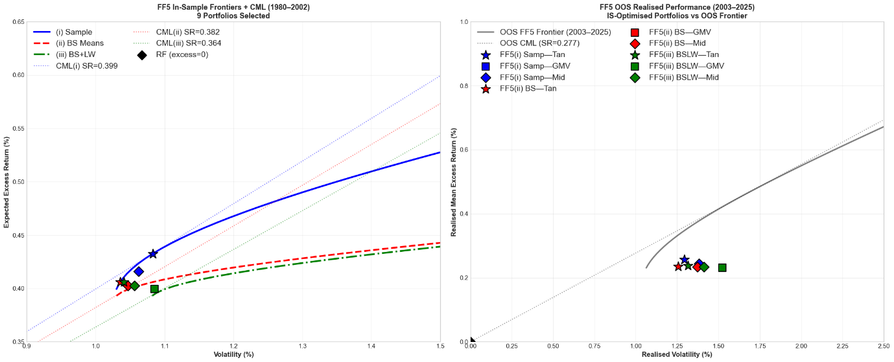
Figure 7.2: FF5 Factor Portfolios – In-Sample vs Out-of-Sample (1980–2002 / 2003–2025)

Portfolio | SR (IS) | SR (OOS) | ΔSR | LW p-value
(i) Samp — Tangency (30 Ind) | 0.337 | 0.082 | −0.255 | 0.001 **
(ii) BS — Tangency (30 Ind) | 0.308 | 0.138 | −0.169 | 0.045 *
(iii) BSLW — Tangency (30 Ind) | 0.302 | 0.156 | −0.146 | 0.095
(i) Samp — GMV (30 Ind) | 0.176 | 0.186 | +0.011 | 0.911
(i) Samp — Tangency (FF5) | 0.400 | 0.199 | −0.201 | 0.062
(iii) BSLW — Tangency (FF5) | 0.390 | 0.180 | −0.210 | 0.054
(i) Samp — GMV (FF5) | 0.368 | 0.152 | −0.216 | 0.059
Table 7.1 – IS vs OOS Sharpe Ratios and Statistical Tests (Selected Portfolios)
The LW bootstrap (preferred over JK for non-normal, serially correlated returns) confirms significant IS→OOS deterioration for the unconstrained sample tangency portfolio across both universes (p = 0.001 for Industry; p ≈ 0.06 for FF5). GMV portfolios show no significant decay (p > 0.90 for Industry), confirming their dependence on the covariance matrix rather than noisy mean estimates produces greater OOS stability (Jagannathan and Ma, 2003). All 17 IS-optimised portfolios fall below the OOS frontier, confirming that fixed IS weights do not remain mean-variance efficient out-of-sample.

Task 8 – Robustness and Portfolio Stability
Using the same in-sample / out-of-sample split as Task 7 (1980–2002 / 2003–2025), we assess whether simple robustness adjustments improve portfolio stability. Table 8.1 reports in-sample (IS) and out-of-sample (OOS) Sharpe ratios for four approaches: (A) unconstrained optimisation, (B) 10% position cap, (C) Michaud-style resampling (50 bootstrap draws), and (D) an expanded 35-asset universe (30 industries plus the Fama–French five factors). The equal-weight (1/N) portfolio is included as a benchmark. Portfolios are optimised in-sample and held fixed out-of-sample.

Strategy | SR (IS) | SR (OOS) | ΔSR | OOS σ | OOS μ
Unconstrained – Tangency | 0.337 | 0.082 | −0.255 | 6.29% | 0.65%
Unconstrained – GMV | 0.175 | 0.186 | +0.011 | 3.62% | 0.81%
10% Cap – Tangency | 0.204 | 0.209 | +0.005 | 3.60% | 0.89%
10% Cap – GMV | 0.180 | 0.191 | +0.011 | 3.92% | 0.89%
Resampled – Tangency | 0.211 | 0.214 | +0.003 | 3.60% | 0.91%
Resampled – GMV | 0.161 | 0.203 | +0.042 | 3.53% | 0.85%
Equal weight (1/N) | 0.135 | 0.185 | +0.049 | 4.80% | 1.02%
35-Asset – Tangency | 0.713 | 0.193 | −0.520 | 1.00% | 0.19%
35-Asset – GMV | 0.442 | 0.158 | −0.284 | 1.29% | 0.20%
Table 8.1: In-Sample vs Out-of-Sample Performance (Monthly Excess Returns)
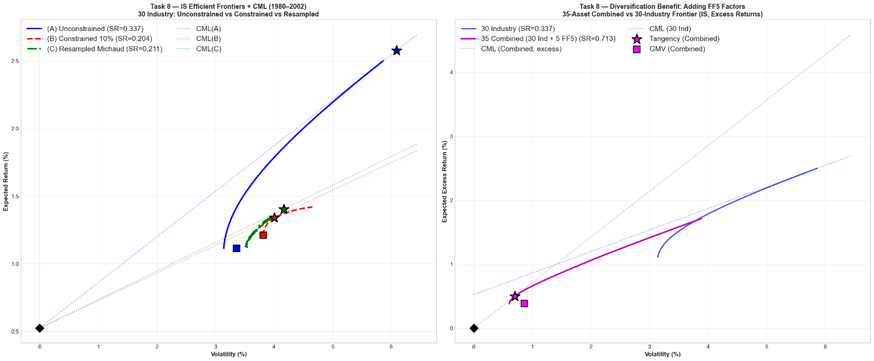Figure 8.1: In-Sample Efficient Frontiers and Capital Market Lines (1980–2002)

Tangency Portfolios Results
The unconstrained tangency portfolio achieves the highest in-sample Sharpe ratio (0.337), but its OOS Sharpe falls sharply to 0.082 (ΔSR = −0.255), with volatility rising to 6.29% per month. This confirms the instability observed in Task 7.
Imposing a 10% weight cap reduces the IS Sharpe to 0.204 but eliminates OOS deterioration (SR(OOS) = 0.209, ΔSR = +0.005), cutting volatility to 3.60%. The resampled tangency produces nearly identical stability (IS SR = 0.211, OOS SR = 0.214). By averaging weights across bootstrap samples, it avoids overfitting to any single realisation of the data.
Expanding the universe to 35 assets dramatically increases the IS Sharpe to 0.713, but the gain reverses OOS (SR = 0.193, ΔSR = −0.520). With N = 35 and only T = 276 months, additional parameters amplify estimation error, resulting in severe OOS performance decay.

GMV and Equal-Weight Results
Across all 30-industry specifications, GMV portfolios exhibit minimal IS–OOS Sharpe changes (ΔSR between +0.011 and +0.042), reflecting their independence from noisy mean return estimates. The resampled GMV achieves the strongest OOS Sharpe (0.203).
The 1/N portfolio delivers an OOS Sharpe of 0.185, substantially outperforming the unconstrained tangency (0.082). The constrained and resampled tangency portfolios modestly exceed 1/N, indicating that optimisation retains value when properly regularised.

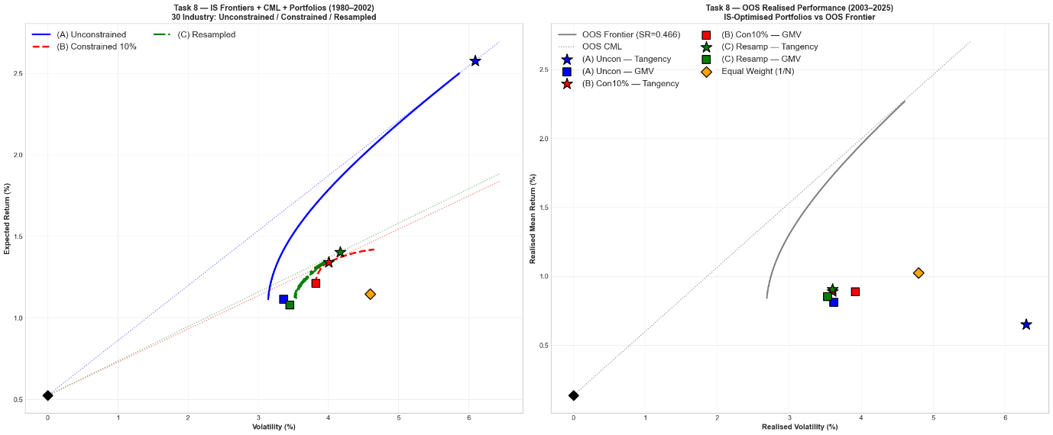Figure 8.2: IS Portfolios vs OOS Realised Performance (2003–2025)

Statistical Evidence
Sharpe ratio equality is tested using Jobson–Korkie (1981) and Ledoit–Wolf (2008) procedures. The LW test is preferred, as it does not require i.i.d. or normality assumptions.

Table 8.2: Sharpe Ratio Equality Tests
Comparison | JK p-value | LW p-value
Unconstrained Tangency: IS → OOS | p < 0.001 | p = 0.001
10% Cap Tangency: IS → OOS | p < 0.001 | p = 0.960
Resampled Tangency: IS → OOS | p < 0.001 | p = 0.986
10% Cap vs Uncon. Tangency (OOS) | p < 0.001 | p = 0.035
Resampled vs Uncon. Tangency (OOS) | p < 0.001 | p = 0.025
1/N vs Uncon. Tangency (OOS) | p < 0.001 | p = 0.121

The LW test confirms significant IS–OOS deterioration for the unconstrained tangency (p = 0.001). Neither the capped nor resampled portfolios exhibit significant deterioration (p > 0.96). Both regularised tangency portfolios significantly outperform the unconstrained benchmark OOS (p = 0.035 and 0.025 respectively), indicating that the improvement reflects genuine robustness rather than sampling variation.

Conclusion
The unconstrained tangency portfolio is highly efficient in-sample but unreliable out-of-sample. Simple regularisation, either through position limits or resampling, substantially stabilises performance at modest in-sample cost. GMV portfolios remain comparatively stable, whereas expanding the asset set without more data deteriorates out-of-sample performance. Optimisation only adds value when estimation risk is controlled.

Task 9 – Mutual Fund Performance Assessment
We assess the performance of three mutual funds against the market portfolio, the FF5 practical proxies, and the tangency portfolios constructed in Tasks 2 and 6. The three funds are described in Table 9.1. VFINX is included as a passive benchmark; FMAGX and AGTHX are actively managed large-cap growth funds. All regressions use monthly excess returns with the longest available overlapping sample for each benchmark.

Table 9.1: Fund Characteristics
Ticker | Fund | Style | Inception | Exp. Ratio
VFINX | Vanguard 500 Index | Passive (S&P 500) | 1976 | 0.14%
FMAGX | Fidelity Magellan | Active Large-Cap Growth | 1963 | 0.67%
AGTHX | Growth Fund of America | Active Large-Cap Growth | 1973 | 0.62%

Table 9.2: Alpha Estimates and Sharpe Ratios by Benchmark (Monthly Excess Returns, Feb 1980–Dec 2025)
Fund | CAPM α (%) | t | FF5-Proxy α (%) | t | Tangency α (%) | t | OOS SR
VFINX | −0.025 | −0.73 | −0.006 | −0.79 | −0.125 | −0.79 | 0.153
FMAGX | +0.497 | +3.80 | +0.552 | +2.60 | +0.444 | +1.98 | 0.224
AGTHX | +0.311 | +2.77 | +0.743 | +3.24 | +0.329 | +1.58 | 0.199
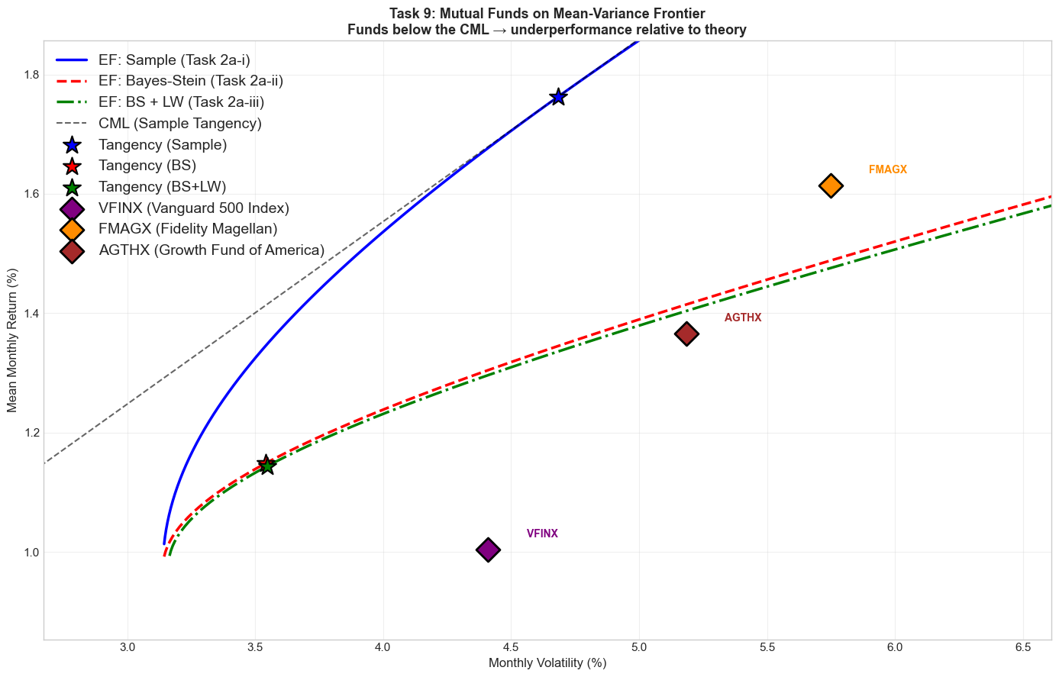
Figure 9.1: Mutual Funds on the Mean–Variance Frontier

VFINX – Vanguard 500 Index (Passive)
As expected for a passive S&P 500 tracker, VFINX produces near-zero alpha across all benchmarks: α = −0.025%/month under CAPM (t = −0.73, insignificant) and effectively zero under the FF5 proxies (α = −0.006%, t = −0.79, R² = 0.9995). The fund's full-sample Sharpe ratio of 0.153 lies below the in-sample tangency portfolio’s Sharpe ratio. The negative tangency alpha (−0.125%) reflects that the in-sample tangency portfolio represents the maximum Sharpe portfolio within the sample. This is a particularly demanding benchmark.

FMAGX – Fidelity Magellan (Active)
FMAGX generates a significant positive CAPM alpha of +0.497%/month (t = 3.80), suggesting genuine outperformance over the market. Under the FF5 proxies, alpha remains positive at +0.552%/month (t = 2.60) and becomes only marginally significant against the tangency portfolio (α = +0.444%, t = 1.98). The large negative loading on IWD (β = −0.46) and positive loading on SPY (β = 1.47) indicate a strong growth tilt. Much of the apparent CAPM alpha reflects systematic factor exposure rather than stock selection skill. The fund's Sharpe ratio of 0.224 remains below the in-sample tangency portfolio.

AGTHX – Growth Fund of America (Active)
AGTHX also shows significant CAPM alpha (+0.311%/month, t = 2.77), which grows to +0.743%/month under FF5 proxies (t = 3.24) — the largest alpha in the sample. This increase reflects that the FF5 proxy model partially fails to capture AGTHX's style exposures, as the R² actually falls from 0.784 to 0.726, suggesting the fund holds assets not well spanned by these proxies. As with FMAGX, the tangency alpha is positive but insignificant (t = 1.58). The fund's Sharpe ratio of 0.199 lies below the in-sample tangency portfolio.

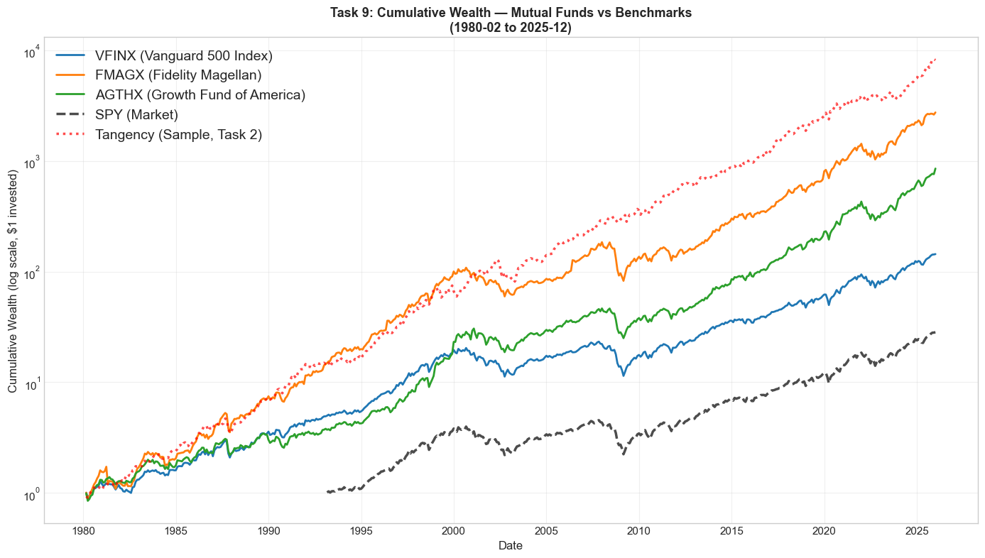Figure 9.2: Cumulative Wealth: Funds vs Benchmarks

Conclusion
All three funds underperform the in-sample tangency portfolio, which by construction delivers the highest Sharpe ratio in the sample. The passive fund (VFINX) correctly shows α ≈ 0 across all benchmarks. The active funds show significant CAPM alphas, but these diminish or become insignificant when controlling for factor exposures, indicating that apparent skill partly reflects systematic tilts toward growth and large-cap equities. The tangency portfolio is uniformly the most demanding benchmark.

Bibliography
Chopra, V.K., Hensel, C.R. and Turner, A.L. (1993) 'Massaging Mean-Variance Inputs: Returns from Alternative Global Investment Strategies', Financial Analysts Journal, 49(4), pp. 88–98.
DeMiguel, V., Garlappi, L. and Uppal, R. (2009) 'Optimal versus Naive Diversification: How Inefficient Is the 1/N Portfolio Strategy?', Review of Financial Studies, 22(5), pp. 1915–1953.
Elton, E.J. and Gruber, M.J. (1997) 'Modern Portfolio Theory, 1950 to Date', Journal of Banking & Finance, 21(11–12), pp. 1743–1759.
Faff, R.W. (2003) 'Creating Fama and French Factors with Style', Financial Review, 38(2), pp. 311–322.
Fama, E.F. and French, K.R. (1993) 'Common Risk Factors in the Returns on Stocks and Bonds', Journal of Financial Economics, 33(1), pp. 3–56.
Fama, E.F. and French, K.R. (2015) 'A Five-Factor Asset Pricing Model', Journal of Financial Economics, 116(1), pp. 1–22.
Jagannathan, R. and Ma, T. (2003) 'Risk Reduction in Large Portfolios: Why Imposing the Wrong Constraints Helps', Journal of Finance, 58(4), pp. 1651–1684.
Jensen, M.C. (1968) 'The Performance of Mutual Funds in the Period 1945–1964', Journal of Finance, 23(2), pp. 389–416.
Jobson, J.D. and Korkie, B.M. (1981) 'Performance Hypothesis Testing with the Sharpe and Treynor Measures', Journal of Finance, 36(4), pp. 889–908.
Jorion, P. (1985) 'International Portfolio Diversification with Estimation Risk', Journal of Business, 58(3), pp. 259–278.
Ledoit, O. and Wolf, M. (2008) 'Robust Performance Hypothesis Testing with the Sharpe Ratio', Journal of Empirical Finance, 15(5), pp. 850–859.
Markowitz, H. (1952) 'Portfolio Selection', Journal of Finance, 7(1), pp. 77–91.
Markowitz, H. (1959) Portfolio Selection: Efficient Diversification of Investments. New York: Wiley.
Michaud, R.O. (1989) 'The Markowitz Optimization Enigma: Is “Optimized” Optimal?', Financial Analysts Journal, 45(1), pp. 31–42.
Sharpe, W.F. (1966) 'Mutual Fund Performance', Journal of Business, 39(1), pp. 119–138.
Tobin, J. (1958) 'Liquidity Preference as Behaviour Towards Risk', Review of Economic Studies, 25(2), pp. 65–86.

